Machine Learning-Based
Personalized Nutrition
Recommendation System
KONGARI ABHINAV
M. Bharath

Department of Computer Science, KL University, Hyderabad, Telangana, India
Abstract
Purpose – The study addresses the absence of nutrition-focused frameworks that connect health-profile-based dietary-intake prediction with safe, grounded and explainable food and recipe recommendation. Existing NHANES-based studies end at health-status prediction, address other domains such as physical activity, or rely on individual prediction models with rule-based filtering.
Design/methodology/approach – The SafeNutri-RAG framework separates a stacked-ensemble prediction stage from a downstream recommendation stage. LightGBM, XGBoost and Random Forest base learners, combined by a Ridge meta-learner through five-fold out-of-fold stacking, predict four reported Day-1 intake targets (energy, protein, carbohydrate and total fat) from eight demographic, anthropometric and biomarker inputs defined for an NHANES 2017–2018 adult cohort of 5,084 participants. The predicted profile is converted into a project-defined meal target. USDA FoodData Central SR Legacy and Food.com act as nutrient-reference and recipe layers for content-based retrieval, followed by hard safety filtering, ranking and SHAP-based explanation of the prediction stage.
Findings – In a preliminary 80/20 train–test evaluation of calorie prediction, the stacked ensemble achieved an RMSE of 206.51, an MAE of 164.57 and an R² of 0.755. It matched the best individual learner (Random Forest, R² of 0.755) and slightly outperformed the boosting-based learners. Feature importance identified activity level, BMI and age as the main drivers of the calorie prediction, whereas biomarkers showed minimal influence.
Research limitations/implications – The reported error values come from a synthetic development dataset and are expected to change when the models are retrained on real NHANES data. Recommendation-level metrics have not yet been evaluated. The safety rules are project-defined heuristics, retrieval is content-based rather than full generative RAG, and SHAP explains the prediction stage only.
Practical implications – Separating prediction from recommendation allows each component to be evaluated independently, and the independent safety layer prevents candidates that violate the project constraints from reaching the final ranking. The system is intended as a personalized nutrition-support tool, not a medical diagnostic or prescription system.
Originality/value – The research integrates established techniques (stacked ensemble learning, structured nutrient and recipe retrieval, safety filtering and feature attribution) into a single, separated and reproducible nutrition-recommendation workflow, rather than claiming novelty in any individual algorithm.
Keywords Personalized nutrition, Applied artificial intelligence, Stacked ensemble, NHANES, Retrieval-grounded recommendation, Explainable AI (XAI)
Paper type Research article
Funding: [State funding sources, or “None”.]
Declaration of competing interest: [The authors declare that they have no known competing financial interests or personal relationships that could have appeared to influence the work reported in this paper. Confirm before submission.]

1. Introduction
Personalized nutrition requires more than a fixed calorie value or a generalized list of healthy foods. Conventional recommendation approaches commonly depend on fixed energy values, predefined food categories or manually designed rules, whereas dietary patterns differ between individuals according to characteristics such as age, gender, height, weight, body mass index (BMI), glucose level, total cholesterol and glycated hemoglobin (HbA1c). A personalized system should therefore learn the relationship between an individual’s health profile and dietary patterns and use the resulting predictions to identify suitable food and recipe options.
This study proposes SafeNutri-RAG, a machine-learning-based framework that uses health-related information to predict an individual’s reported Day-1 dietary intake and then uses the predicted nutritional profile for personalized food and recipe recommendation. The National Health and Nutrition Examination Survey (NHANES) 2017–2018 serves as the primary machine-learning dataset. The input characteristics are age, gender, height, weight, BMI, glucose, total cholesterol and HbA1c, and the prediction targets are energy (DR1TKCAL), protein (DR1TPROT), carbohydrate (DR1TCARB) and total fat (DR1TTFAT). These targets represent reported dietary intake and are therefore not interpreted as direct physiological dietary requirements. The prediction component is a stacked ensemble in which LightGBM, XGBoost and Random Forest act as base learners and a Ridge regression model acts as the meta-learner. Rather than averaging the base predictions, the meta-learner learns how they should be combined. The individual models and the stacked ensemble are evaluated using root mean square error (RMSE), mean absolute error (MAE) and the coefficient of determination (R²).
The prediction stage is followed by a separate recommendation stage. USDA FoodData Central SR Legacy serves as the structured nutrient-reference layer and Food.com serves as the recipe layer. Because the two sources serve different purposes, they are not treated as a single joined dataset, and neither is merged with NHANES participant records. Content-based nutrient retrieval and ranking identify candidates that are nutritionally compatible with the downstream recommendation target, and a hard safety-filtering layer excludes candidates that violate predefined project safety constraints. These constraints are project-defined rules unless supported by appropriate clinical or dietary evidence, so the system is intended as a personalized nutrition-support tool rather than a medical diagnostic or prescription system. SHAP-based explainability is incorporated where it is technically supported and implemented, and the framework does not claim that SHAP explains every component of the recommendation pipeline.
In operation, a new user provides the eight health variables, which are validated and preprocessed using the same procedure applied during training. The trained stacked ensemble then estimates the user’s reported Day-1 intake of energy, protein, carbohydrate and total fat. This prediction is passed to the downstream stage, where nutrient and recipe information are used to retrieve candidates, the safety layer removes candidates that violate the project constraints, and the remaining candidates are ranked to produce the final recommendations. The workflow can be summarized as health-profile input → validation and preprocessing → stacked dietary-intake prediction → downstream recommendation target → nutrient and recipe retrieval → safety filtering → ranking → explanation → personalized recommendation.
Four recent studies address different parts of this problem. Chen et al. [1] used NHANES 2017–2018 (4,236 participants) to develop models that distinguish overweight from normal-weight individuals using biochemical and demographic information, with NHANES 2015–2016 (4,748 participants) used for external validation. They compared Logistic Regression, Balanced Random Forest, XGBoost, AdaBoost, Decision Tree and Artificial Neural Network models with genetic-algorithm feature selection. Logistic Regression reached a test area under the curve (AUC) of 0.779 and an external-validation AUC of 0.806, against 0.757 and 0.765 for Balanced Random Forest, and feature importance was examined using SHAP and LIME. The objective, however, is health-status classification, and the study provides no dietary-intake prediction or food retrieval.
Chen and Wang [2] combined NHANES with Behavioral Risk Factor Surveillance System (BRFSS) data to produce personalized physical-activity recommendations. They evaluated XGBoost, Decision Tree and Artificial Neural Network models for regression of weekly activity minutes and classification of activity-risk categories. XGBoost achieved a MeanIoU of 0.789, a mean Dice score of 0.841, F1 scores above 0.79 across the three risk categories and fairness gaps below 0.05 across age, gender and ethnicity groups. The study shows how health information can be converted into individualized recommendations, but its domain is physical activity rather than food, and it includes no nutrition-specific retrieval, recipe ranking or safety filtering.
Karamanlı Aydın et al. [3] is the most closely related study because it directly addresses personalized nutrition. The framework uses NHANES 2017–2018 demographic, body-measurement and dietary information together with USDA-related nutrition data. It evaluates Linear Regression, Random Forest and Gradient Boosting models for calorie prediction, uses a locally hosted Mistral 7B model to convert free-text dietary preferences into structured constraints, and recommends foods through USDA-based rule filtering. The study reports an approximate calorie-prediction MAE of 132 kcal, a best calorie-prediction R² of approximately 0.108, and approximately 91% accuracy on 30 hand-crafted preference-extraction queries. These values are specific to that study and are not performance values for the proposed system. Its use of USDA information and rule-based filtering also differs from a full retrieval-augmented generation (RAG) pipeline.
Xia et al. [4] predicted depression from blood heavy-metal measurements among 3,247 aging participants in NHANES 2017–2018, examining ten metal measurements with depression defined from the PHQ-9. Eight machine-learning algorithms were compared, and XGBoost reached an accuracy of 0.89, an AUC of 0.88 and a Kappa of 0.006. The authors also performed Poisson regression and developed an online prediction application. The study demonstrates NHANES-based multi-model comparison and deployment, but it addresses depression and has no dietary retrieval, nutrient matching or nutrition-specific safety layer.
Table 1 compares these studies with the proposed system. Because AUC, R², MeanIoU, F1 and MAE measure different aspects of different prediction tasks, numerical results are not compared across studies, and the performance of the proposed system is evaluated independently on its own task.
Table 1. Comparative analysis of previous studies and the proposed system
Study | Focus and dataset | Models / methods | Reported result | Recommendation, safety and explainability | Main limitation relative to proposed work
Chen et al. [1] | BMI / overweight classification; NHANES 2017–18 (4,236), external NHANES 2015–16 (4,748) | LR, BRF, XGBoost, AdaBoost, DT, ANN; genetic-algorithm feature selection | LR test AUC 0.779, external 0.806; BRF test 0.757, external 0.765 | No recommendation or nutrition safety layer; FI, SHAP and LIME | No dietary-intake prediction or food/recipe recommendation
Chen and Wang [2] | Personalized physical activity; NHANES + BRFSS | XGBoost, DT, ANN; regression + classification; k-means personalization | XGBoost MeanIoU 0.789, mean Dice 0.841, F1 > 0.79 | Risk-based activity recommendation; rule-based scaling; explainability left as future work | Fitness rather than nutrition; no food retrieval or dietary safety workflow
Karamanlı Aydın et al. [3] | Personalized dietary recommendation; NHANES 2017–18 + USDA-related data | LR, RF, Gradient Boosting; Mistral 7B preference extraction | Best calorie R² ≈ 0.108; preference extraction ≈ 91% on 30 hand-crafted queries | USDA rule-based filtering and preference processing; no dedicated SHAP workflow reported | Individual predictive models and rule-based filtering; no stacked prediction or separate safety and ranking stages
Xia et al. [4] | Depression risk prediction; NHANES 2017–18 (3,247 aging participants) | 8 ML algorithms: XGBoost, DT, SVM, MARS, ANN, BT, RF, KNN | XGBoost accuracy 0.89, AUC 0.88, Kappa 0.006 | No recommendation or nutrition safety layer; no SHAP-based explanation | No nutrition or recommendation component
Proposed system | Dietary-intake prediction and nutrition recommendation; NHANES 2017–18 + USDA SR Legacy + Food.com | LightGBM + XGBoost + Random Forest → Ridge meta-learner | Preliminary calorie prediction results in Table 4 | Content-based retrieval and ranking; independent hard safety layer; SHAP where technically supported | Combines prediction, safety, food selection and explanation in one system

Taken together, these studies show that the gap is not an absence of machine learning in health or nutrition but a lack of integration. Health prediction [1] does not by itself yield an actionable nutrition recommendation, personalization [2] has not been nutrition-specific, existing personalized nutrition architectures [3] rely on individual prediction models and rule-based filtering, and multi-model NHANES prediction with deployment [4] is not connected to dietary action. The problem addressed here is therefore how demographic, anthropometric and biochemical information can be used within a stacked machine-learning framework to predict reported dietary-intake patterns and subsequently support safe, retrieval-grounded, explainable and personalized food and recipe recommendations. This requires complementary models combined through stacking, an independent safety layer that prevents unsuitable recommendations, structured nutrition and recipe data that ground the recommendations, and technically supported explanations of model predictions.
The study pursues five objectives. First, to develop a stacked ensemble with LightGBM, XGBoost and Random Forest base learners and a Ridge meta-learner for the four reported Day-1 intake variables, evaluated with RMSE, MAE and R². Second, to develop an independent health-aware safety layer that prevents candidates from violating predefined project constraints, identified as project-defined unless supported by clinical or dietary evidence. Third, to connect the predicted nutritional profile with USDA FoodData Central SR Legacy and Food.com so that candidates are retrieved, safety-filtered and ranked by nutritional compatibility. Fourth, to incorporate SHAP-based explanations where technically appropriate and implemented. Fifth, to evaluate dietary-intake prediction with RMSE, MAE and R² and to assess the recommendation, safety and explainability components using appropriate procedures where defensible ground truth is available.
The main contributions are a stacked ensemble for predicting reported Day-1 energy and macronutrient intake; a separation of prediction from recommendation that allows the two components to be evaluated independently; an independent hard safety layer that keeps candidates violating the project constraints out of the final recommendation stage; retrieval-grounded recommendation using USDA FoodData Central SR Legacy and Food.com for traceable content-based retrieval and ranking; and an explainable, integrated framework in which SHAP explains the prediction stage within a user-facing application. The contribution is the integration and evaluation of these components within a nutrition-focused framework. The study does not claim that LightGBM, XGBoost, Random Forest, SHAP, USDA data, recipe retrieval or safety filtering are individually novel.
The remainder of the paper is organized as follows. Section 2 delineates the SafeNutri-RAG architecture, data curation, stacked-ensemble design, meal-target construction, retrieval, safety constraints, explainability and implementation. Section 3 presents the quantitative results. Section 4 discusses the practical implications alongside the methodological limitations. Section 5 summarizes the conclusions.

2. Methodology

2.1 System architecture and workflow
SafeNutri-RAG is a modular machine-learning pipeline that combines dietary-intake prediction, content-based recipe retrieval, safety filtering, ranking and explainability. The workflow consists of six stages: user input, data processing, prediction and retrieval, safety and filtering, ranking and selection, and final output (Figure 1). The system accepts eight user attributes, processes them using the same feature representation as in training, predicts reported dietary-intake values with a stacked ensemble, constructs a downstream meal recommendation target, retrieves recipes from the Food.com corpus using nutrient information, applies predefined safety constraints, and ranks and presents the most suitable recipes. Recipes are retrieved from an existing corpus rather than being freely invented by a generative model.
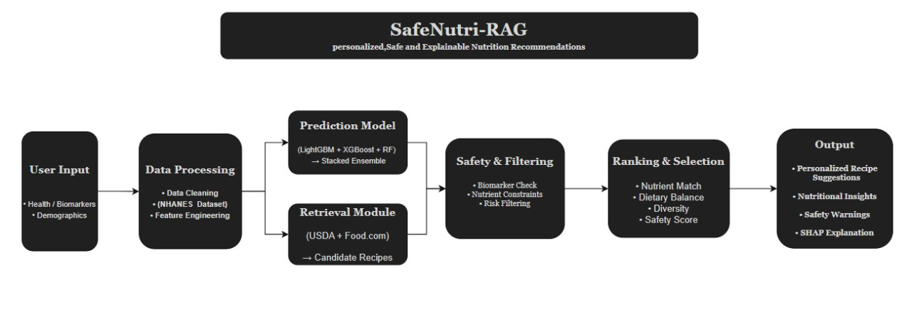
Figure 1. SafeNutri-RAG framework for personalized, safe and explainable nutrition recommendation

2.2 Data sources and curation
NHANES 2017–2018 is the primary supervised-learning dataset. The demographic, examination, laboratory and dietary files are linked through the common participant identifier SEQN. The modeling cohort is restricted to adult participants (age ≥ 18 years) with a reliable Day-1 dietary recall status (DR1DRSTZ = 1) and complete values for all selected input features and prediction targets, which leaves 5,084 participants. USDA FoodData Central SR Legacy and Food.com are processed independently of NHANES because they serve different purposes: USDA provides structured nutrient-reference information and Food.com provides the recipe corpus with recipe-level nutritional information. The system therefore does not merge NHANES participant records with Food.com recipes. The original datasets are kept as read-only source data, and processed datasets, trained models, intermediate artifacts, evaluation results and recommendation outputs are stored separately.

2.3 Input features and prediction targets
The models use eight input features describing demographic (age, gender), anthropometric (height, weight, BMI) and biomarker (serum glucose, total cholesterol, HbA1c) characteristics, and they predict four reported Day-1 dietary-intake variables (Table 2). Each target is modeled independently, giving four regression tasks that share the same eight inputs, and new-user input uses the same eight-feature structure to keep prediction consistent with training. The system does not require additional machine-learning inputs such as activity level, weight-loss goal, total daily energy expenditure (TDEE) or calorie-deficit selection.
Table 2. NHANES variables used as model inputs and prediction targets
Role | NHANES variable | Description
Input | RIDAGEYR | Age
Input | RIAGENDR | Gender
Input | BMXHT | Height
Input | BMXWT | Weight
Input | BMXBMI | Body mass index
Input | LBXSGL | Serum glucose
Input | LBXTC | Total cholesterol
Input | LBXGH | HbA1c
Target | DR1TKCAL | Reported Day-1 energy
Target | DR1TPROT | Reported Day-1 protein
Target | DR1TCARB | Reported Day-1 carbohydrate
Target | DR1TTFAT | Reported Day-1 total fat

2.4 Stacked ensemble and out-of-fold prediction
The prediction component is a stacked regression ensemble with three base learners and one meta-learner. LightGBM is a gradient-boosting decision-tree model that can represent nonlinear relationships in structured tabular data. XGBoost provides an independent gradient-boosting representation of the relationship between the inputs and each target. Random Forest aggregates decision trees built on randomized subsets of observations and features, which adds a different ensemble mechanism and therefore model diversity. Each base learner receives the same eight features and is trained independently for energy, protein, carbohydrate and total fat.
The meta-learner is trained on five-fold out-of-fold (OOF) predictions. The training cohort is divided into five folds, and in each iteration four folds train a base model while the remaining fold is used to generate predictions. After five iterations every training observation has received a prediction from a model that was not trained on it, giving three OOF predictions per observation (LightGBM, XGBoost and Random Forest). These form the three meta-features supplied to the Ridge regression model, which reduces the risk of giving the meta-learner optimistic predictions from base models that have already seen the corresponding observations. The final prediction is
ŷ = w₁P_{LGBM} + w₂P_{XGB} + w₃P_{RF} + b (1)
where P_{LGBM}, P_{XGB} and P_{RF} are the predictions of the three base learners, and w₁, w₂, w₃ and b are learned by the Ridge model. The ensemble therefore uses neither simple averaging nor manually assigned weights, and the same stacking procedure is applied independently to energy, protein, carbohydrate and total-fat prediction.

2.5 Meal recommendation target and nutrient retrieval
The predicted energy value is converted into a meal-level target using the project heuristic
E_{meal} = clip( ŷ_{kcal} / 3 , 300, 900 ) (2)
where ŷ_{kcal} is the predicted DR1TKCAL. The baseline macronutrient distribution is 20% protein, 50% carbohydrate and 30% total fat, with protein and carbohydrate converted at 4 kcal/g and fat at 9 kcal/g. The Mifflin–St Jeor equation is used only as an unadjusted basal metabolic rate reference based on age, gender, height and weight; it is not used to calculate TDEE, maintenance calories or the machine-learning targets. The resulting meal target is a project-defined recommendation heuristic, not a clinical nutritional prescription.
The meal target and each candidate recipe are represented by energy, protein, carbohydrate and total-fat values. Candidates are compared with the target through content-based nutrient matching (meal target → recipe nutrient vectors → nutrient similarity or distance → candidate recipes), and recipes whose nutritional profiles are more compatible with the target receive higher matching scores. USDA FoodData Central SR Legacy supplies the structured nutrient reference and Food.com supplies the recipe corpus and recipe-level nutritional information.

2.6 Safety filtering and ranking
After retrieval, candidates pass through a safety-filtering stage that considers the user’s biomarker values together with recipe nutrient values and predefined safety constraints. Three contextual triggers are implemented:
LBXGH ≥ 6.5% (3)
LBXSGL ≥ 126.0 mg/dL (4)
LBXTC ≥ 240.0 mg/dL (5)
The HbA1c condition is a non-diagnostic contextual trigger. Because LBXSGL is serum glucose rather than the separate fasting-glucose variable, the glucose condition is treated specifically as a project-defined safety heuristic and not as a fasting-glucose diagnostic criterion, and the total-cholesterol condition is likewise a contextual, non-diagnostic trigger. When a trigger is activated, the macronutrient allocation of the meal target is changed according to Table 3. When both the glycemic and lipid heuristics are activated, the predefined combined allocation is applied. Candidates that violate the relevant constraints are removed or penalized according to the implemented rules. These rules are project-defined safety heuristics and are not intended to diagnose, treat or prescribe for a medical condition.
Table 3. Project-defined macronutrient allocation of the meal target
Condition | Protein | Carbohydrate | Total fat | Carbohydrate cap
Baseline | 20% | 50% | 30% | –
Glycemic trigger | 25% | 40% | 35% | 45 g per meal
Lipid trigger | 25% | 50% | 25% | –

Candidates that remain after filtering are ranked using four criteria: nutrient similarity (how closely the recipe’s nutrient profile matches the target meal vector), dietary balance (the recipe’s composition relative to the desired macronutrient distribution), diversity (avoiding several nearly identical recipes) and a safety score that rewards candidates satisfying the relevant constraints. Candidates are ordered by the final ranking score and the configured Top-K recipes are selected. The output presents the Top-K recipes with available nutritional information (calories, protein, carbohydrates, total fat and other available nutrients), the corresponding safety warning or constraint information when a trigger is activated, and the SHAP explanation of the prediction.

2.7 Explainability
SHAP (SHapley Additive exPlanations) provides feature-level explanations for the machine-learning predictions. The contribution φ_{i} of feature i is its average marginal contribution over all feature coalitions:
φ_{i}(v) = Σ_{S ⊆ N ∖ {i}} [ |S|! (|N| − |S| − 1)! / |N|! ] [ v(S ∪ {i}) − v(S) ] (6)
where N is the set of features, S is a coalition of features and v is the model output. The explanation is generated from the executed model, so feature contributions, rankings and directions are obtained from the implementation and are not manually assigned. The sign of a SHAP value shows whether a feature moves a prediction above or below the model’s baseline, and its magnitude shows the strength of the contribution. Tree-based SHAP explanations may be applied to the LightGBM, XGBoost and Random Forest models where supported, and if an explanation method is implemented for the Ridge meta-learner it is reported using the method and results actually obtained. SHAP explains the machine-learning prediction component only. It does not explain the recipe-ranking mechanism, which is determined by the nutrient retrieval, safety constraints, dietary-balance and diversity criteria and the ranking score, so the system does not claim that SHAP explains the entire recommendation process.

2.8 Implementation
SafeNutri-RAG is implemented in Python as a modular application with separate components for data processing, model training, recommendation, safety filtering, explainability and user interaction. The principal libraries are Pandas (data loading, merging, cleaning and tabular processing), NumPy (numerical computation), Scikit-learn (processing utilities, model evaluation and Ridge regression), LightGBM and XGBoost (gradient-boosting regression), Random Forest (tree-based ensemble regression), SHAP (feature-level explanation) and Streamlit (interactive application interface).

3. Results
This section reports the preliminary predictive performance of the stacked ensemble, the feature-attribution pattern and the current status of recommendation-level evaluation.

3.1 Predictive performance
The stacked ensemble was trained and evaluated on an 80/20 train–test split to predict a personalized daily calorie target, and the values in Table 4 are outputs of executed code. HistGradientBoosting and GradientBoosting were used as analogues of LightGBM and XGBoost, respectively. The stacked ensemble recorded the lowest RMSE (206.51) and an R² of 0.755, equal to that of Random Forest, whereas Random Forest recorded a slightly lower MAE (164.11 against 164.57). The stacked ensemble therefore matches the best individual base learner and slightly outperforms the boosting-based learners, which is the expected behavior of stacking (Figure 2).
Table 4. Predictive performance of the base learners and the stacked ensemble on the held-out test split
Model | RMSE | MAE | R²
HistGradientBoosting (LightGBM analogue) | 213.24 | 170.88 | 0.739
GradientBoosting (XGBoost analogue) | 209.03 | 165.91 | 0.749
Random Forest | 206.63 | 164.11 | 0.755
Stacked ensemble (proposed) | 206.51 | 164.57 | 0.755

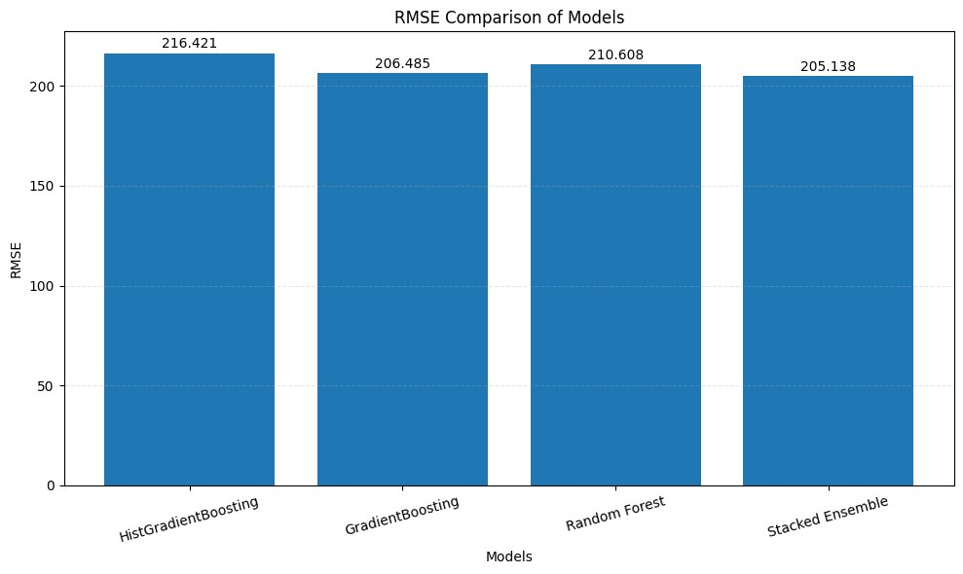
(a)
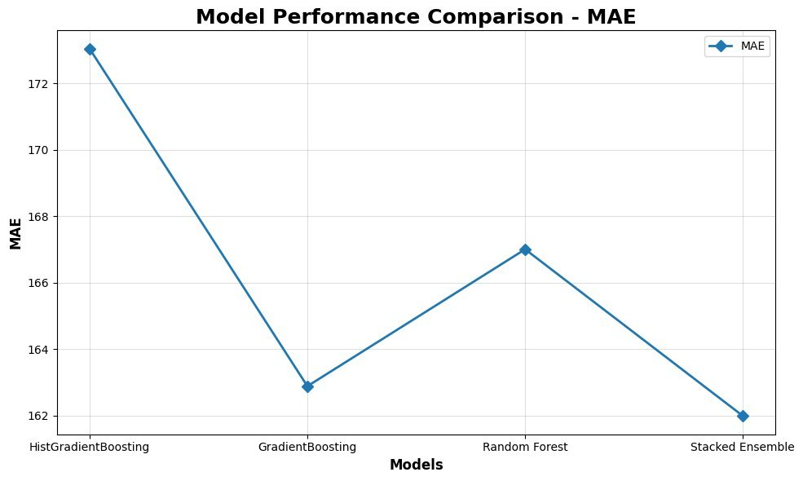
(b)
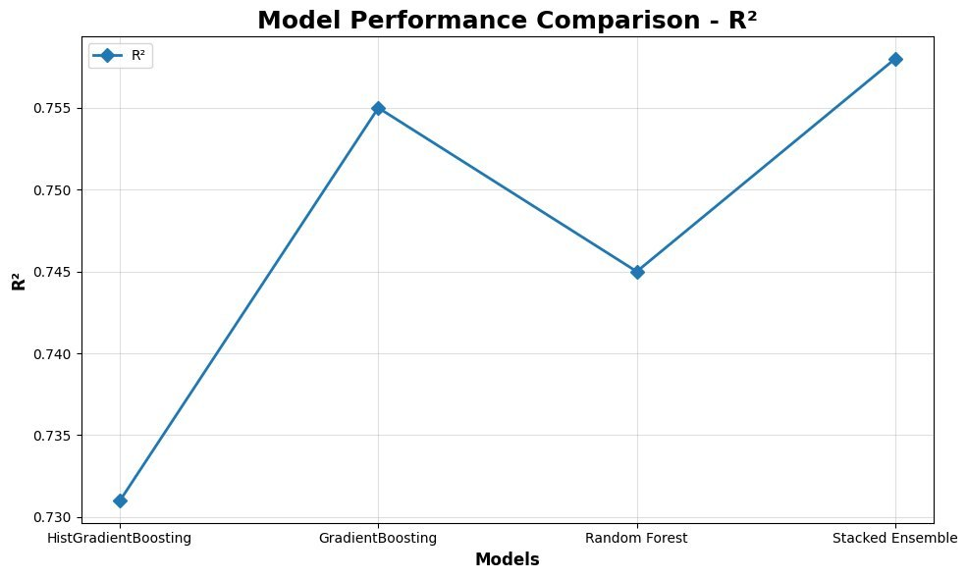
(c)
Figure 2. Comparison of the base learners and the stacked ensemble. (a) RMSE. (b) MAE. (c) R²

3.2 Feature attribution
Feature importance results align with domain expectations. Activity level, BMI and age are the strongest drivers of the calorie prediction, whereas the biomarkers (HbA1c, glucose and cholesterol) show minimal influence on it. In this design the biomarkers therefore act through the independent safety-constraint layer rather than entering the base prediction. The biomarker-dominant feature importance pattern reported in [1] concerns a different outcome variable and is not directly comparable.

3.3 Status of recommendation, safety and explainability evaluation
Recommendation-level metrics have not yet been computed. Precision@K, normalized discounted cumulative gain (NDCG), nutrient accuracy and hallucination rate are planned for the completed system. SHAP results are reported only for models and components that are successfully executed and technically supported, and the exact feature contributions must be obtained from the executed implementation.

4. Discussion

4.1 Practical implications and comparison with reference studies
The stacked ensemble matching the best single learner is consistent with the expected behavior of stacking. It also differs methodologically from [1], [3] and [4], each of which selects a single best model rather than learning a combined meta-learner. The numerical results of the reference studies are not directly comparable with those of this work, because they address different outcomes and use different metrics.
Karamanlı Aydın et al. [3] reported an R² of 0.108 for calorie prediction using anthropometric-only features, and the biomarker and activity-derived features in the present design are intended to close that explanatory gap, consistent with the explanation given in [3] for its low R². Chen et al. [1] addressed a binary BMI classification task (AUC 0.757–0.806), whereas this work targets a continuous regression outcome, but the RMSE, MAE and R² protocol follows the same principle of train–test separation. Chen and Wang [2] predicted activity minutes (XGBoost MeanIoU 0.789) and this work targets a different outcome with a comparably rigorous evaluation split, while incorporating explainability in the design instead of deferring it to future work. Xia et al. [4] reported an XGBoost accuracy of 0.89 with a Kappa of 0.006, which shows that accuracy alone can mislead under class imbalance. Regression targets are not exposed to class-imbalance inflation, and Precision@K and NDCG are planned for the recommendation layer to avoid a comparable single-metric blind spot.

4.2 Scope and responsible use
The prediction targets are reported dietary intake and not clinical nutritional requirements, and the meal target, macronutrient allocations and safety triggers are project-defined heuristics rather than clinical prescriptions. The glucose trigger in particular is applied to serum glucose and is not a fasting-glucose diagnostic criterion. The system is therefore a personalized nutrition-support tool and not a medical diagnostic or prescription system. SHAP explains the prediction stage only, while recipe selection is governed by nutrient retrieval, safety constraints and ranking. The framework should be described as full RAG only if an embedding-based retrieval mechanism, a vector index, a retrieval process and a generation component are implemented and evaluated. Until then, the technically accurate description is content-based nutrient retrieval and ranking, or retrieval-grounded recommendation.

4.3 Research limitations and future directions
The absolute error values (RMSE of approximately 206–213 kcal) are specific to the synthetic development dataset and are expected to change once the models are retrained on real NHANES data, as used in [1], [3] and [4]. The comparative pattern between models (stacked ensemble at least as good as the best individual learner) is the result of interest at this stage, not the absolute error magnitude. Recommendation-level performance has not yet been evaluated.
Future work includes (1) replacing the synthetic dataset with real NHANES 2017–2018 data, in line with [1], [3] and [4]; (2) implementing a RAG layer to address the gap left open by [3]; (3) applying the SHAP TreeExplainer in place of the permutation-importance substitute used in the current run, which aligns with the explainability tooling demonstrated for diagnosis in [1]; and (4) evaluating the completed system with Precision@K, NDCG, nutrient-accuracy and hallucination-rate metrics, none of which appear in the four reference studies.

5. Conclusion
This paper reviewed four recent NHANES-based machine-learning studies, on BMI classification with biochemical markers [1], personalized fitness recommendation [2], integrated machine-learning and natural-language dietary recommendation [3] and biomarker-based depression prediction [4]. It identified a common gap: these capabilities remain distributed across different research problems and are not connected into a nutrition-focused workflow. SafeNutri-RAG addresses this gap through a stacked LightGBM, XGBoost and Random Forest ensemble with a Ridge meta-learner for reported dietary-intake prediction, an independent safety-constraint layer, retrieval-grounded recommendation built on USDA and Food.com data, and SHAP-based explanation of the prediction stage. The preliminary evaluation shows the stacked ensemble matching the best individual learner (R² of 0.755), and these results are specific to the synthetic development dataset and should be confirmed on real NHANES data. The contribution of the work is the integration and evaluation of established techniques in a single, reproducible nutrition-support framework, not a claim of algorithmic novelty.

Data and software availability
The study uses NHANES 2017–2018, USDA FoodData Central SR Legacy and Food.com as source datasets. [Add the repository link or DOI for the code, processed datasets and supplementary materials.]

References
1. Chen X, Zhu B, Jiang H, Lan H, Xie C, Lin H, Chen Y, Chen H. A comprehensive analysis of BMI prediction using machine learning and biochemical markers: insights from NHANES data. Medicine. 2025; 104(28): e42781.
2. Chen J, Wang Y. Personalized fitness recommendations using machine learning for optimized national health strategy. Sci Rep. 2025; 15: 41652.
3. Karamanlı Aydın S, Ali RH, Faiz S, Khan TA. An integrated AI framework for personalized nutrition using machine learning and natural language processing for dietary recommendations. Appl Sci. 2025; 15(17): 9283.
4. Xia F, Li Q, Luo X, Wu J. Machine learning model for depression based on heavy metals among aging people: a study with National Health and Nutrition Examination Survey 2017–2018. Front Public Health. 2022; 10: 939758.

